Workshop Notes by Michael White
Included here are notes from workshops that I have been using over the past five to ten years.
Download: Workshop Notes by Michael White
CONTENTS:
Externalising conversations exercise
Statement of position maps 1 & 2
Therapeutic posture 9 Re-authoring conversations
Re-membering conversations
Definitional ceremony and outsider-witness responses
Attending to the consequences of trauma
Distinctions between Traditional Power and Modern Power
Addressing personal failure
EXTERNALISING CONVERSATIONS EXERCISE
This exercise has been developed to assist people to explore externalising conversations. It requires the participation of three or more people. One person volunteers to role-play a problem, another to role-play the person who is experiencing the problem (in this exercise, this person is called the problem’s "subject", and it can be the person who is considered to have the actual problem), and the third to role-play an investigative reporter (a detective-type journalist who is good at exposing subterfuge and corruption). If there are more than three people joining the exercise, there can be more than one investigative reporter, or there can be observers who share their reflections on the exercise at the end.
There are three parts to the exercise. In the first part, the person who is playing the investigative reporter interviews the person who is playing the problem about the problem’s successes. In the second part, the person who is playing the investigative reporter interviews the person who is playing the problem about the problem’s failures. During these parts of the exercise, the person who is role-playing the subject listens in carefully without interrupting. In the third part of the exercise, the person who is playing the subject will have the opportunity to share, with the other players, their experience of these two interviews.
PART 1
After a decision has been made about the problem to be played, and after roles have been assigned, the person who is playing the problem is informed that problems tend to be rather arrogant and boastful, and that it is rarely difficult to get them to talk about their successes and to "spill the beans" on how they have achieved these successes. In fact, they are so "full of themselves" that they usually give away their secrets and bring themselves undone as soon as they are given even the slightest opportunity to do so. For this reason, the person who is playing the problem will find themselves in quite a cooperative mood during their interview with the investigative reporter.
It is important that the investigative reporter stay on track with their task. It is not their job to cure the problem, or in any way attempt to reform it or to rehabilitate it. Instead they should assume the position from which they might simply develop an expose on the life and the identity of the problem. This is sometimes difficult for the person who is playing the investigative reporter to achieve, and requires some conscious effort to break from the tendency of wanting to be helpful.
The investigative reporter has many options for questions in the development of an expose on the problem’s successes. These questions can open and inquiry into:
a. the problem’s influence in the different areas of the subject’s life (for example, its effects on the subject’s relationships with others, its impact on the subject’s feelings, its interference in the subject’s thoughts, its effects on the subject’s story about who they are as a person, how it has the subject treating their own life, and so on)
b. the strategies, the techniques, the deceits, and the tricks that the problem has resorted to in its efforts to get the upper-hand in the subject’s life,
c. the special qualities possessed by the problem that it depends upon to undermine and to disqualify the subject’s knowledges and skills. This can include an inquiry into the powerful ways that the problem speaks in its efforts to impose its authority on the subject’s life,
d. the purposes that guide the problem’s attempts to dominate the subject’s life, and the dreams and hopes that the problem has for the subject’s life,
e. who stands with the problem, and an investigation into the various forces are in league with it,
f. the plans that the problem has ready to put into action should its dominance be threatened.
PART 2
Despite appearances to the contrary, problems are never totally successful in their ambitions for people’s lives and relationships. However, they are usually loathe to admit this and to talk openly about their failures to achieve these ambitions, which ordinarily they do their best to cover up. Therefore, when commencing to interview the problem about its failures, it is important for the investigative reporter to be acquainted with some prior knowledge of the facts of these failures. These are facts that simply cannot be denied. Because of this, in this part of the exercise, following an initial display of bravado, problems grudgingly begin to confess to these failures.
Investigative reporters have many options for questions that are effective in developing an expose on the problem’s failures. These can include an inquiry into:
a. the territories of life over which the subject still has some influence despite the problem’s attempts to totally dispossess the subject,
b. the counter-techniques, counter-strategies, and the tricks that have been developed by the subject that have at times been effective in "throwing a spanner in the works" of the problem’s efforts to get the upper hand in the subject’s life,
c. the special qualities, knowledges, and skills possessed by the subject that have proven difficult for the problem to undermine and to disqualify. This can include an inquiry into the nature of the "self-talk" that the subject has developed to challenge the problem’s attempt to impose its authority on their life,
d. the purposes and commitments that guide the subject’s efforts to challenge the attempts of the problem to dominate the subject’s life, and that have frustrated the dreams and the hopes of the problem,
e. who stands with the subject (relatives, friends, acquaintances, teachers, therapists, and so on), and the part they have played in denying the problem’s desires and wishes,
f. the options that are available to the subject for taking advantage of the problem’s vulnerabilities and for the reclamation of the territories of their own life.
This exercise is demoralising of the problem, who exits from it rather dispirited. Therefore, it is important that the person who has been playing the problem does what is necessary, by way of de-roling, to break from the problem persona. It helps for this person to have the space to talk of their experience of both parts of the exercise. The person who plays the investigative reporter does not need to de-role, as this exercise opens new options for consultations that are less onerous, less weighty. It opens possibilities for a different sort of collaboration with people who seek help, and for the expression of curiosity in this work.
PART 3
At this point in the exercise, the person who has been playing the subject talks of their experiences of Parts 1 and 2 of the exercise. They also have the opportunity to comment on the accuracy of the portrayal of the problem. Following this, the persons who have been playing the problem and the investigative reporter talk of their experience of the first two parts of the exercise, and then all parties to the exercise are invited to share their thoughts on proposals for action that might undermine the influence of the problem in the person’s life.
STATEMENT OF POSITION MAPS 1 & 2
Statement of Position Map 1
Four categories of inquiry, that constitute externalising conversations, and that contribute to the:
1. Negotiation of an experience-near, particular, and non-structuralist definition of the problem/concern (as an alternative to an experience-distant, global, and structuralist definition of the problem/concern).
2. Mapping of the effects/influence of the problem through the various domains of living in which complications are identified (home, workplace, school, peer contexts; familial relationships, one’s relationship with oneself, friendships; purposes, hopes, dreams, aspirations and values; life’s horizons, one’s future possibilities, etc.).
3. Evaluation of the effects/influence of the problem in these domains of living (Is this okay with you?; How do you feel about this?; How is this by you?; Where do you stand on this?; What it your position on this?; Is this a positive or negative development? Or would you say both a positive and a negative development, or neither of these? Or would you say an in-between development?; and so on).
4. Justification of these evaluations (Why is/isn’t this okay for you?; Why do you feel this way about this development?; How come you’re taking this stand/position on this development?; Would you tell me a story about your life that would help me to understand why you would take this position on this development?; and so on).
Notes:
The four categories of inquiry described here provide an account of the structure of externalising conversations.
Within the context of the second category of inquiry, the therapist does not encourage persons to map the effects/influence of the problem through all domains of life, but just through those that seem most significant to the persons seeking consultation.
In response to explorations shaped by the fourth category of inquiry, persons invariably put to words valued conclusions about their lives and identities (for example, conclusions about preferred purposes, longings, desires, wishes, values, beliefs, pledges, hopes, dreams, commitments, and so on). These contradict many of the negative conclusions, reached by people, which are associated with their experiences of various problems and predicaments. These valued conclusions open possibilities for people to take action in relation to these problems and predicaments, and also provide a basis for the identification of unique outcomes: "You reached this conclusion without much hesitation. Can you think of any events of your life that would reflect this conclusion that … ?"
Supplement to Notes on Statement of Position Map 1:
Mapping Externalising Conversations
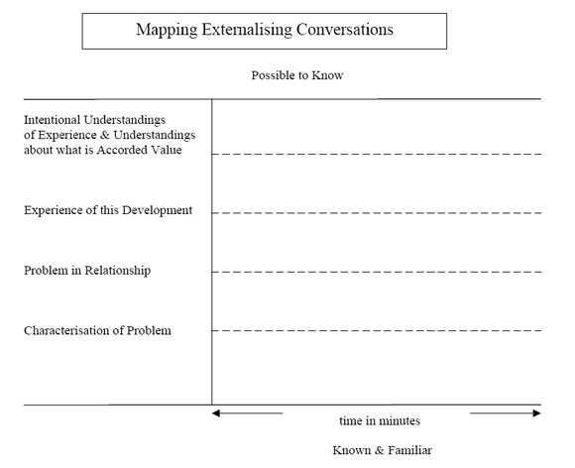
Statement of Position Map 2
Four categories of inquiry providing a scaffold that contributes to options for people to load the unique outcomes/exceptions/problem-solving skills of their lives with significance.
1. Negotiation of an experience-near and particular definition of the unique outcome/exception/problem-solving skill.
2. Mapping of the effects/potential effects of the unique outcome/exception/problem-solving skill in those various domains of living in which these effects might be identified (home, workplace, school, peer contexts; familial relationships, one’s relationship with oneself, friendships; purposes, hopes, dreams, aspirations and values; life’s horizons, one’s future possibilities, etc.).
3. Evaluation of the effects/potential effects of the unique outcome/exception/problem-solving skill in these domains of living (Is this okay with you?; How do you feel about this?; How is this by you?; Where do you stand on this?; What it your position on this?; Is this a positive or negative development? Or would you say both a positive and a negative development, or neither of these? Or would you say an in-between development?; and so on).
4. Justification of these evaluations (Why is/isn’t this okay for you?; Why do you feel this way about this development?; How come you’re taking this stand/position on this development?; Would you tell me a story about your life that would help me to understand why you would take this position on this development?; and so on).
Notes:
In response to specific developments in people’s lives, it can be very tempting for therapists to respond enthusiastically to what they construe to be a unique outcomes, and in so doing:
a. engage in efforts to convince persons that they could take more notice of and appreciate these developments,
b. try to point out the consequences or potential implications of, or possibilities associated with, such developments,
c. take a strongly positive position on these consequences, implications, and possibilities, and
d. justify their position on these developments by giving voice to a range of positive conclusions about the lives and the identities of the people seeking consultation.
In responding to the developments of people’s lives in this way, therapists become quite centred and relatively non-influential. These developments are judged to be significant and weighty to therapists, but not by the people who seek consultation. In such circumstances, it is the therapists who are taking a primary position on various developments, not the people who consult therapists. This closes the door on options
for the development of the sort of partnership that is the outcome of therapists joining people in their position on the various developments of their lives.
The "statement of position map 2" can assist therapists to maintain a decentred posture in their consultations, and contributes to the scaffolding of therapeutic conversations that provide the opportunity for people seeking consultation to attribute significance to various developments of their lives, developments that might otherwise be neglected.
Supplement to Notes on Statement of Position Map 2:
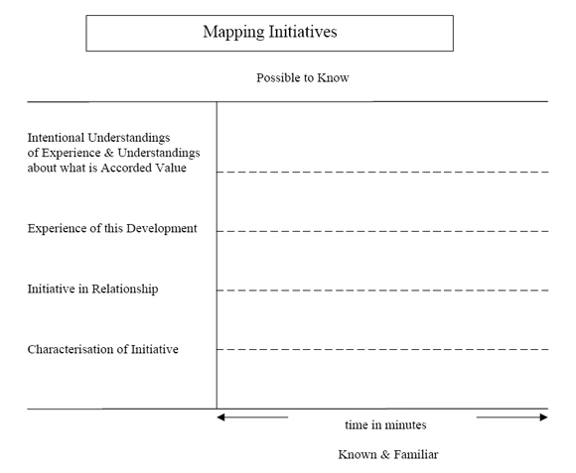
THERAPEUTIC POSTURE
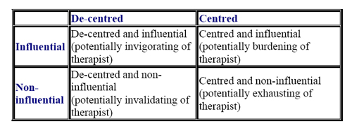
Notes:
It is the intention of the therapist to take up a "decentred and influential" posture in conversations had with the people who consult them – to develop therapeutic practices that make it possible for him/her to occupy the top-left quadrant.
The notion "decentred" does not refer to the intensity of the therapist’s engagement (emotional or otherwise) with people seeking consultation, but to the therapist’s achievement in according priority to the personal stories and to the knowledges and skills of these people. In regard to the personal stories of people’s lives, in the context of this achievement, these people have a "primary authorship" status, and the knowledges and skills that have been generated in the history of their lives are the principal considerations.
The therapist is influential not in the sense of imposing an agenda or in the sense of delivering interventions, but in the sense of building a scaffold, through questions and reflections, that makes it possible for people to:
a) more richly describe the alternative stories of their lives,
b) step into and to explore some of the neglected territories of their lives, and to
c) become more significantly acquainted with the knowledges and skills of their lives that are relevant to addressing the concerns, predicaments and problems that are at hand.
RE-AUTHORING CONVERSATIONS
1. When people consult therapists they tell stories. They speak about what brings them to therapy, and usually provide an account of what lead up to their decision to seek help. They also usually share their understanding of the history of their problem/predicament/dilemma. In doing this, people link the events of their lives in sequences that unfold through time according to a theme/plot. Along with this, people routinely refer to the figures/protagonists who feature in the story, and share with therapists their conclusions about the identity of these figures/protagonists.
2. Re-authoring conversations invite people to do what they routinely do - that is, to link events of their lives in sequences through time according to a theme/plot. However, in this activity, people are assisted to identify the more neglected events of their lives - the unique outcomes or exceptions - and are encouraged to take these into alternative story lines.
3. In the first place, unique outcomes or exceptions provide a starting point for re-authoring conversations. They provide a point of entry into the alternative story lines of people’s lives that, at the outset of these conversations, become visible as thin traces, which are full of gaps, and are not clearly named. As these conversations proceed, therapists build a scaffold through questions that encourage people to fill these gaps. This is a scaffold that assists people to recruit their lived experience, that stretches and exercises their imagination and their meaning-making resources, and that is engaging of their fascination and curiosity. As an outcome, the alternative story lines of people’s lives are thickened and more deeply rooted in history, the gaps are filled, and these story lines are clearly named.
4. In developing this scaffold, therapists traffic in "landscape of action" and "landscape of identity" questions. People’s stories of life and of personal identity can be considered to compose "landscapes of the mind" (following Jerome Bruner), which are constituted of landscapes of action (composing events, linked in sequence, through time, and according to a theme/plot) and landscapes of identity (composing identity conclusions that are shaped by contemporary identity categories of culture). It is through scaffolding questions that these alternative landscapes of the mind are richly described.
5. Re-authoring conversations re-invigorate peoples efforts to understand what it is that is happening in their lives, what it is that has happened, how it has happened, and what it all means. In this way, these conversations encourage a dramatic re-engagement with life and with history, and provide options for people to more fully inhabit their lives and their relationships. There are some parallels between the skills of re-authoring conversations and the skills required to produce texts of literary merit (the book "Narrative Means to Therapeutic Ends" was originally published in 1989 as "Literary Means to Therapeutic Ends"). Amongst other things, texts of literary merit encourage, in the reader, a dramatic re-engagement with many of their own experiences of life. It is in this dramatic re-engagement that the gaps in the story line are filled, and the reader lives the story by taking it over as their own.
6. As with the skills that construct texts of literary merit, the scaffolding provided by the questions of re-authoring conversations make it possible for people to address and to fill the gaps in these alternative landscapes of the mind. These questions are not oriented to the already known in ways that precipitate the sort of thoughtlessness that is the outcome of boredom and an acute familiarity with the subject. And these questions are not oriented to what might become known in ways that precipitate the sort of thoughtlessness that is the outcome of fatigue and of failure to identify the unfamiliar. As in the development of any skills, competence in the expression of these scaffolding questions is acquired through practice, more practice, and then more practice
7. As re-authoring conversations evolve, they provide conditions under which it becomes possible for people to step into the near future of the landscapes of action of their lives. Questions are introduced that encourage people to generate new proposals for action, accounts of the circumstances likely to be favourable to these proposals for action, and predictions about the outcome of these proposals. Rarely are these questions introduced ahead of the rich development of landscape identity conclusions.
8. In the first place, people are likely to respond to landscape of identity questions by generating identity conclusions that are informed by the well known structuralist categories of identity - needs, motives, attributes, traits, strengths, deficits, resources, properties, characteristics, drives and so on. These structuralist identity conclusions invariably provide a poor basis for knowledge of how to proceed in life. As these conversations further evolve, there is opportunity for people to generate identity conclusions that informed by the well known non-structuralist categories of identity – intentions and purposes, values and beliefs, hopes, dreams and visions, commitments to ways of living, and so on. It is in the context of the development of these non-structuralist identity conclusions that people find the opportunity to progressively distance from their lives, and it is from this distance that they become knowledged about matters of how to proceed. It is from this distance that people find the opportunity for more significant dramatic engagements with their own lives, and to take further steps in the habitation of their existence.
Supplement to Notes on Re-Authoring Conversations
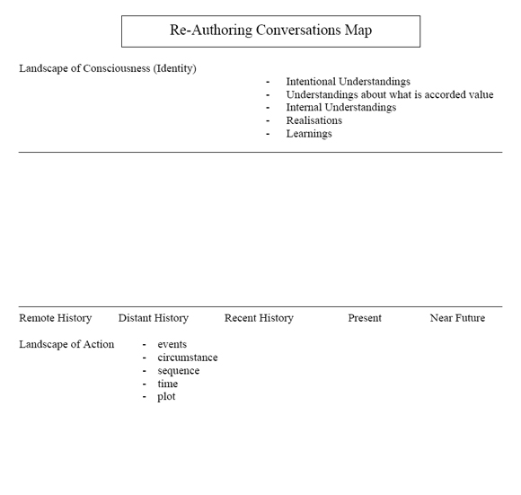
RE-MEMBERING CONVERSATIONS
I drew the "re-membering" metaphor from the work of Barbara Myerhoff (1982,1986), a cultural anthropologist. These notes represent some of the implications for therapeutic practice that I have derived in my explorations of this metaphor. Re-membering conversations are therapeutic conversations that:
1. Evoke ‘life’ as a ‘membered’ club, ‘identity’ as an ‘association’ of life.
2. Contribute to a multi-voiced sense of identity, rather than the single-voiced sense of identity which is a feature of the encapsulated self that is the vogue of contemporary western culture.
3. Open possibilities for the revision of one’s membership of life: for the upgrading of some memberships and the downgrading of others; for the honouring of some memberships and for the revoking of others; for the granting of authority to some voices in regard to matters of one’s personal identity, and for the disqualification of other voices in regard to this matter.
4. Are richly describing of the preferred accounts of identity and knowledges of life and skills of living that have been co-generated in the significant memberships of people’s lives. In reviewing these memberships, these accounts of identity and these knowledges and skills can be explored in their particularities. In these explorations many significant discoveries, realisations, conclusions, learnings, problem-solving practices, and so on, become richly described. This contributes very significantly to a person’s sense of being knowledged, which provides a basis for them to development specific proposals about how they might to go forward in their lives.
5. Re-membering conversations are not about passive recollection, but about purposive engagements with the significant figures of one’s history, and with the identities of one’s present life who are significant or potentially significant. These figures and identities do not have to be directly known in order to be identified as significant to persons lives. For example, these figures and identities may be the authors of books that have been important to persons, or characters in movies or comics. And these figures do not have to be people. For example, they may be the stuffed toys of a person’s childhood, or a favourite pet, and so on.
6. Re-membering conversations are often initiated through two sets of inquiry:
a) The first set of inquiry invites:
i. a recounting of what the significant figure contributed to the person’s life (figure’s contribution to person’s life),
ii. the person to enter the consciousness of this figure on matters of the person’s identity, initiating a rich description of the ways in which this connection shaped/had the potential to shape the person’s sense of who they are and what their life is about (person’s identity through the eyes of the figure).
b) The second set of inquiry invites:
i. a recounting of what the person contributed to the life of this figure (person’s contribution to the figure’s life), and
ii. the person to enter the consciousness of this figure on matters of this figure’s identity, initiating a rich description of the ways in which this connection shaped/had the potential to shape this figure’s sense of who they were and what their life was about (implications of this contribution for the figure’s sense of identity).
Supplement to Notes on Re-Membering Conversations:
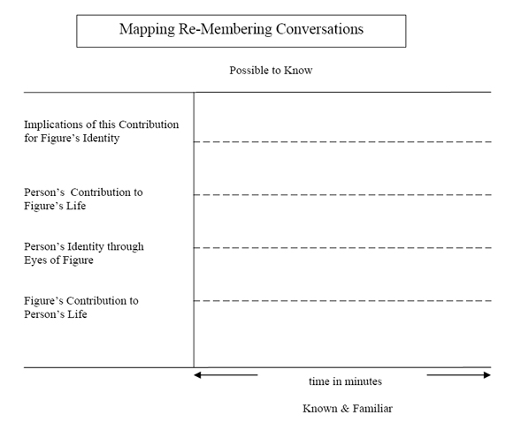
NOTE:
For further discussion and illustration of re-membering practices, see "Re-membering" and "Remembering and professional lives" in Narratives of Therapists’ Lives (1997, Dulwich Centre Publications).
Myerhoff, B. 1982: ‘Life history among the elderly: Performance, visibility and re-membering’. In Ruby, J. (ed) A Crack in the Mirror: reflexive perspectives in anthropology. Philadelphia: University of Pennsylvania Press.
Myerhoff, B. 1986: ‘Life not death in Venice: Its second life’. In Turner, V. and Bruner, E. (eds). 1986: The Anthropology of Experience. Chicago: University of Illinios Press.
DEFINITIONAL CEREMONY AND OUTSIDER-WITNESS RESPONSES
DEFINITIONAL CEREMONY
1. The definitional ceremony metaphor structures the therapeutic arena as a context for the rich description of people’s lives, identities and relationships. This metaphor structures rituals that are acknowledging of and ‘regrading’ of people’s lives, in contrast to many of the common rituals of modern culture that are judging of and ‘degrading’ of lives. I have drawn the definitional ceremony metaphor from the work of Barbara Myerhoff (1982,1986), a cultural anthropologist, and have developed therapeutic applications of this metaphor.
2. The structuring of the therapeutic arena according to the definitional ceremony metaphor is linked to a poststructuralist or non-structuralist account of identity. According to this account, the fashioning of identity is:
a) a public and social achievement, not a private and individual achievement,
b) shaped by historical and cultural forces, rather than by the forces of nature, however nature might be conceived of, and
c) dependent upon deriving a sense of authenticity that is an outcome of social processes that are acknowledging of one’s preferred claims about one’s identity and about one’s history, rather than being the outcome of the identification, through introspection, of the essences or elements of the ‘self’, and of the expression of these essences, however this self might be conceived of.
3. In this therapeutic arena, people are provided with the option of telling/performing the stories of their lives before an audience of outsider witnesses. The outsider witnesses respond to these tellings with retellings of certain aspects of what has been heard. These retellings are shaped by specific traditions of acknowledgement.
4. Definitional ceremony structures are usually constituted of multi-layered tellings and retellings of the stories of people’s lives.
a) Tellings (undertaken by those whose lives are at the centre of the ceremony)
b) Retellings of tellings (first retelling – usually undertaken by the outsider witnesses)
c) Retellings of retellings (second retelling – usually undertaken by those whose lives are at the centre of the ceremony)
d) Retellings of retellings of retellings (third retelling – usually undertaken by the outsider witnesses, or by a secondary group of outsider witnesses)
e) And so on.
5. A disruption of dialogue across the interfaces of these tellings and retellings is a characteristic of definitional ceremony. When the outsider witnesses are in the audience position, they are strictly in that position. When the people whose lives are at the centre of definitional ceremony are in the audience position, they are strictly in that position.
6. Through these tellings and retellings, many of the alternative themes or counter-plots of people’s lives are thickened, and the stories of people’s lives become linked through these themes, and through the values, purposes, and commitments expressed in them.
7. The retellings of definitional ceremony structures are authenticating of people’s preferred claims about their lives and their identities, and have the effect of pushing forward the counter-plots of people’s lives - they contribute to options for action in people’s lives that would not otherwise be available to them.
8. The responses of the outsider witnesses are not shaped by contemporary practices of applause (giving affirmations, pointing out positives, congratulatory responses, and so on) - or, for that matter, any of the common and routine practices of judgement (negative or positive judgement). Also, it is not the place of outsider witnesses to give opinions or to make declarations about other people’s lives, to hold up their own lives and actions as examples to others, or to introduce moral stories or homilies under the guise of a retelling. And these responses do not constitute serial monologues. Rather, outsider witnesses engage each other in conversations about what was heard, and about their responses to what was heard - outsider witnesses routinely interview each other about their responses, and in so doing link and build upon each other’s contributions
9. Definitional ceremony is ‘moving’ of all participants in that it contributes to options for them to be become other than who they were. This is about being moved in the sense of being transported, in the sense of being elsewhere in life on account of this participation.
References
Myerhoff, B. 1982: ‘Life history among the elderly: Performance, visibility and re-membering’. In Ruby, J. (ed) A Crack in the Mirror: reflexive perspectives in anthropology. Philadelphia: University of Pennsylvania Press.
Myerhoff, B. 1986: ‘Life not death in Venice: Its second life’. In Turner, V. and Bruner, E. (eds). 1986: The Anthropology of Experience. Chicago: University of Illinios Press.
OUTSIDER-WITNESS RESPONSES
Here I present four categories of response that can be considered by reflecting-team members as they prepare themselves for an outsider-witness retelling. These can also be of assistance to therapists as they get ready to interview outsider witnesses when this group is not composed of professional counsellors who are familiar with the tradition of acknowledgment that characterises definitional ceremony. These categories of response are not exclusive, but provide an example of how the contribution of outsider witnesses might be structured within the terms of this tradition of acknowledgement. For further discussion of these practices, see "Reflecting team-work as definitional ceremony revisited" in Reflections on Narrative Practice (2000), "Definitional ceremony in Narratives of Therapists’ Lives (1997) and "Reflecting team-work as definitional ceremony" in Re-authoring Lives, Interviews and Essays (1995). These texts are available from Dulwich Centre Publications.
The retellings of the outsider witnesses do not constitute an account of the whole of the content of what is heard by them, but centre on those aspects of the tellings that most significantly engage their fascination.
Categories of response
1. Identifying the expression
As you listen to the stories of the lives of the people who are at the centre of the definitional ceremony, which expressions caught your attention or captured your imagination? Which one’s struck a chord for you?
2. Describing the image
What images of people’s lives, of their identities, and of the world more generally, did these expressions evoke? What did these expressions suggest to you about these people’s purposes, values, beliefs, hopes, dreams and commitments?
3. Embodying responses
What is it about your own life/work that accounts for why these expressions caught your attention or struck a chord for you? Do you have a sense of which aspects of your own experiences of life resonated with these expressions, and with the images evoked by these expressions?
4. Acknowledging Transport
How have you been moved on account of being present to witness these expressions of life? Where has this experience taken you to, that you would not otherwise have arrived at, if you hadn’t been present as an audience to this conversation? In what way have you become other than who you were on account of witnessing these expressions, and on account of responding to these stories in the way that you have?
Notes:
The sample questions that I have provided here are for illustration purposes. They give an account of how outsider-witness responses might be organised in order to reproduce the class of acknowledgment that is characteristic of definitional ceremony. Many other questions can be constructed around each of these categories of outsider-witness response.
Supplement to Notes on Definitional Ceremony & Outsider Witness Re-tellings:
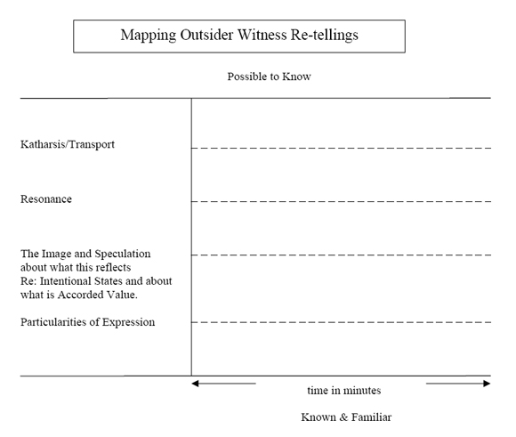
ATTENDING TO THE CONSEQUENCES OF TRAUMA
These notes were prepared for workshop participants to supplement explorations of the relevance of and application of narrative ideas and practices with people seeking consultation in regard to experiences of significant trauma.
There are contemporary understandings of psychological pain and emotional distress as an outcome of trauma that obscure many of the complexities and particularities of people’s experiences of trauma, and of their expressions of this experience.
Some of these understandings draw a ‘natural’ and linear link between trauma and psychological pain/emotional distress, and these can lead to a thin grasp of the consequences of therapeutic conversations.
Therapeutic conversations informed by some of these contemporary understandings can contribute to the construction of a significantly fragile or vulnerable sense of self, and leave people with a keen sense that their person is ever susceptible to being trespassed upon in ways that they will be hard-pressed to defend themselves against. This closes down options for people to take action in regard to their predicaments in life, and is diminishing of their general sense of knowing how to proceed in life.
There are other understandings of psychological pain and emotional distress as an outcome of trauma that take in these complexities and particularities, and that bring attention to the responsibility that therapists have in the shaping of therapeutic conversations that will contribute to construction of a ‘robust’ sense of self, rather than a ‘fragile’ sense of self. This is a development of a sense of self that:
a. people find more honouring of their lives;
b. opens options for people to take action in regard to their predicaments in life; and
c. enhances their general sense of knowing how to proceed in life.
1. Pain as testimony
Ongoing psychological pain in response to trauma in the history of people’s lives might be considered a testimony to the significance of what it was that the person held precious that was violated through the experience of trauma. This can include people’s understandings about:
a) cherished purposes for one’s life;
b) prized values and beliefs around acceptance, justice and fairness;
c) treasured aspirations, hopes and dreams;
d) moral visions about how things might be in the world;
e) significant pledges, vows and commitments about ways of being in life, etc.
If psychological pain can be considered to be a testimony to such purposes, values, beliefs, aspirations, hopes, dreams, moral visions, and commitments, then the experienced intensity of this pain can be considered to be a reflection of the degree to which these intentional states were held precious by persons.
In the context of therapeutic conversations these understandings can be identified, resurrected and become richly known. It is within these conversations that people have the opportunity to experience being at one with a range of positive identity conclusions that displace many a negative "truths" of identity that they have been recruited into as an outcome of the traumas they have been subject to.
2. Distress as tribute
Day-to-day emotional distress in response to trauma in people’s histories might be considered a tribute to their ability to maintain a relationship to all of those purposes, values, beliefs, aspirations, hopes, dreams, visions and commitments held precious – to their refusal to relinquish or to be separated from what was so powerfully disrespected and demeaned in the context of trauma, from what it was that they continue to revere.
If such emotional distress can be considered to be a tribute to people’s determination to maintain a relationship to that which was powerfully disrespected and demeaned in the context of trauma, then the experienced intensity of this distress can be considered to be reflection the degree to which the person has continued to revere and maintain a relationship with what it is that they hold precious.
In the context of therapeutic conversations, acknowledgement of people’s refusal to relinquish what was so powerfully disrespected, and explorations of their skills in maintaining a relationship with these intentional states, can be very significantly elevating of their sense of who they are, and of what their lives are about.
3. Pain and Distress as Proclamation of response
Exploring the specifics of this testimony and tribute can provide a basis for identifying people’s responses to the trauma they have been subject to.
People always respond to the crises of their lives, even when these crises are the outcome of trauma under circumstances in which they are relatively powerless to escape the context or to bring about a cessation of what ever it is that they are being subject to.
These responses, that can be considered acts of redress that are shaped by people’s intentional states, are rarely recognised and acknowledged, and often ridiculed and diminished, in the context of trauma. Therefore, rarely are these responses accorded value, and rarely do these become significantly known to the people who initiate them.
This understanding can provide a basis for explorations of the extent to which people’s pain and distress is also a proclamation of their responses to the traumas that they have been subject to. In context of therapeutic conversations, what it is that a person held precious and has continued to revere can become known, and this provides the basis for an inquiry into how this shaped their responses to what they were being put through. This sort of inquiry is one that emphasises actions taken that reflect people’s exercise of personal agency according to specific intentional states, and it is, at times, in the first place, quite speculative.
4. Expressions of pain and distress as movement
In our contemporary world, understandings of human expression are invariably shaped by a time-honoured tradition of dualistic thought. For example, considerations of human expression are routinely shaped by the feeling/meaning, affect/cognition, emotion/thought dualisms. In challenging this tradition of thought, it becomes possible for us to entertain the idea that all expressions of life are units of meaning and experience, and that these expressions are shaping or constituting of life. Expressions of life can be considered movements that are transporting of lives, movements through which people become other than who they were.
When expressions of psychological pain and emotional distress are taken into the sort of dualistic understandings discussed above, these movements in life are rarely recognised and acknowledged, and, as an outcome of this, these take the form of a series of ‘fits and starts’. In these circumstances, the potential for these movements to have significant and enduring shaping effects on people’s lives is mostly lost, and it is very likely that people will derive a sense that their lives are frozen in time.
When expressions of psychological pain and emotional distress can be understood as units of experience and meaning that are shaping or constituting of life, the door is open to an inquiry that is identifying of and richly describing of where these expressions are taking people in their movement through life. It is through such inquiry that the transporting aspects of these expressions can be acknowledged, and that what otherwise might be a series of fits and starts are taken into themes that have enduring effects. It is in the context of such inquiry that people derive a sense of their lives unfolding according to preferred directions.
5. Psychological pain and distress as elements of a legacy
Psychological pain and emotional distress might be understood to be elements of a legacy expressed by people who, in the face of the non-responsiveness of the world around them, remain resolute in their determination that the trauma that they and others have gone through will not be for nothing – that things must change on account of what they have gone through. According to this understanding, despite the absence of a wider acknowledgement that things must change, these people are sentinels who will not let this matter drop, and who have remained on guard against forces that would be diminishing of their experiences, and that would be reproducing of trauma in the lives of others.
Within the context of therapeutic conversations, and by engaging the participation of outsider witnesses to these conversations, the legacy that is represented in expressions of psychological pain and emotional distress can be significantly honoured and joined with by others. The way in which people rely upon their insider experience of trauma in recognising what others have been through, and in responding to others with a compassion that touches their lives, and that evokes a sense of solidarity with them, can be also be significantly acknowledged.
Further, these therapeutic conversations can provide a context for the substantial recognition of how these people, through their expressions of pain and distress in relation to trauma, are inviting others to be more resolute in their position on matters of what is fair and just and what isn’t so.
Discussion
I have provided an account of understandings of psychological pain and day-to-day emotional distress as:
a) a testimony to those intentional states held precious by people;
b) a tribute to people’s maintenance of a relationship with those intentional states that they continue to revere;
c) a proclamation of people’s acts of redress in response to the traumas they have been subject to; and as
d) expressions that are movements in life that shape opportunities for people to become other than who they were,
e)elements of a legacy expressed by people who, in the face of the non-responsiveness of the world around them, remain resolute in their determination that the trauma that they and others have gone through will not be for nothing.
It is in the context of conversations shaped by such understandings that people:
a) derive a robust sense of their identities,
b) experience themselves to be uniquely-abled on account of what they have been through, rather than uniquely-disabled (as in damaged, messed up, etc),
c) achieve a significant reduction in felt experiences of psychological pain, and of emotional distress.
In the context of therapeutic inquiry informed by these understandings, people find safe places in which to stand in the territory of memory – at first islands, then archipelagos, and then continents – that provide them with platforms for speaking of what hasn’t been spoken about, for putting into more significant expression their experiences of trauma, and for the development of a ‘knowing’ about how to proceed in life. It is through the development of these safe places in which to stand in memory that it becomes possible for people to bring their experiences of trauma into the storylines of their lives; that is, to reassociate dissociated memories in a manner that locates these in personal history in a way that assigns beginnings and endings to traumatic experience.
DISTINCTIONS BETWEEN TRADITIONAL AND MODERN POWER
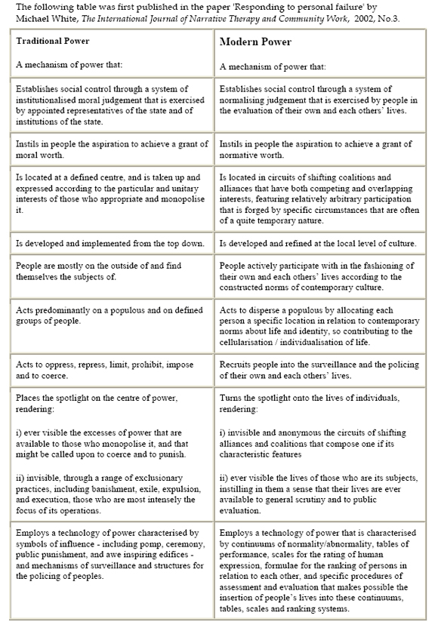
ADDRESSING PERSONAL FAILURE
These notes provide a summary of some of the main points from the article ‘Addressing Personal Failure’ which appeared in The International Journal of Narrative Therapy and Community Work, 2002, number 3. These notes were prepared as a guide to workshop participants in explorations of the phenomenon of personal failure, and as a source of ready reference when participating in the ‘failure conversations exercise’ that is reproduced in the text of the above mentioned article.
Alternative identity projects
It is possible to engage with the sense of personal failure in a way that provides for a reading of this as a refusal of modern power.
In the shadows of personal failure, other knowledges of life and practices of living can be identified and more richly appreciated.
This can provide a foundation for people to more significantly pursue identity projects that do not so completely reproduce the favoured individualities of contemporary culture.
This takes us to considerations about the production of life itself, about the manufacture of identity, about the fabrication of the human subject.
I believe that some appreciation of the processes of the manufacture of identity to be very helpful in the formation of a therapeutic inquiry that sponsors possibilities for the remanufacture of identity.
Foucault studied the history of the fabrication of the human subject, with an emphasis on the constitution of the self as a moral agent. He inquired into the elaboration of one’s relationship to oneself and to one’s life through different eras, and referred to this as the study of ethics.
He concluded that, through different eras, there could be identified four aspects in the constitution of self as a moral agent. He called the first aspect of the constitution of the self as a moral agent the "ethical substance".
1. Ethical substance
That aspect of life that is considered of primary relevance to ethical judgement - whatever it is about our lives that is our responsibility to manage well.
Foucault illustrated the way in which what is deemed relevant as the "ethical substance" changes from one era to the next:
a. for the ancient Greeks it was "pleasure" that had to be managed well (pleasure was to be moderated, and excesses revealed and reigned in),
b. for the early Christians it was forms of "desire", often referred to as concupiscence (desire for the flesh was to be renounced).
c. those aspects of life that are now considered of primary relevance to ethical judgement are categories of the self – one’s essential "feelings", one’s deepest "desires", one’s personal "properties", ones "resources", one’s human "needs", one’s intrinsic "attrib utes", and so on (one’s feelings are to be kept faith with, one’s desires are to be liberated, one’s personal properties are to be cultivated, one’s resources are to be put into circulation and capitalised on, one’s needs are to be satisfied, one’s attributes are to be expressed)
2. Mode of subjectification
Is the mechanism through which people are encouraged or required to recognise their moral obligations in regard to the management of the relevant ethical substances.
Is one to refer to: divine laws; to the laws of nature; to rational rule; or to particular systems of values and principles - for example, like the system of values that is expressed in certain religious or humanist narratives, in ecological conceptions of life, or that is associated with the concept of life as a work of art:
a. For the ancient Greeks it was through aesthetic values that one might appreciate the obligations that must be observed in the pursuit of pleasure.
b. For the early Christians it was through divine law that one might know what obligations s/he has in the management of desire.
c. In the modern era it is through the discourses of "truth" associated with socially constructed norms, and that are expressed in "rational" rule, "natural" law, and personal rights, that people are invited to recognise not their moral obligations, but their normative obligations (in the expression of their essential feelings, the liberation of their desires, the cultivation of their personal properties, the realisation of and in capitalising on their personal resources, the satisfaction of their individual needs, the expression of their intrinsic attributes, and so on).
3. Asceticism
Asceticism is about lifestyle. It is about the self-forming activities that one engages in when observing the obligations that one has to become an ethical subject in the pursuit of an ethical existence.
It is through these self-forming activities that one elaborates an identity and a life that can be considered ethical.
These self-forming activities emphasised by Foucault were what he called the techniques of the self - the techniques that one uses in order to recognise oneself as an ethical subject.
These techniques of the self include all of those self-forming activities that one might engage in to:
i. moderate one’s pleasures (which, as with the ancient Greeks, include personal aesthetic and political considerations, that provide a foundation for one’s ability for caring for the city),
ii. decipher and to modulate one’s desires (which, as with the early Christians, included practices of confession), or to
iii. be true to one’s feelings, liberate one’s desires, cultivate one’s properties, capitalise on one’s resources, satisfy one’s need, express one’s attributes, realise one’s potential, and so on (which includes normalising judgement founded on wide range of technologies of assessment and evaluation).
4. Telos
Telos is about the mode of being or the kind of being that we aspire to be when we are behaving in a moral way, or, in modern times, in ways that provide us with a grant of normative worth.
Telos expresses the goal or the end point in one’s identity project that one seeks to arrive at.
It might be an aspiration to achieve a life that is one of self-mastery, of purity of being, of godliness, or a beautiful life that is artistic in form. It might be a goal to achieve salvation or an eternal life, or perhaps an exalted reputation.
Under the guidance of modern day rationality, it would more commonly be an aspiration to achieve a life of self-possession, of personal fulfilment, of self-actualisation, or one that reflects a pinnacle of liberation of the self.
Practice implications
Personal failure might be testimony to people’s acts of refusal of modern power.
Such acts of refusal do not come "out of the blue", but are founded on modes of life and thought that do not so completely reproduce the cherished individualities of our contemporary world.
These acts of refusal can represent alternative identity projects that contribute to options for people in the remanufacture of their identities.
These understandings sponsor a therapeutic inquiry that:
a. makes possible the identification of people’s refusals of the requirements of modern power,
b. contributes to the rich description of modes of life and thought that do not so completely reproduce the cherished individualities of contemporary culture, and
c. provides a basis for the remanufacture of identities which provide alternatives to those linked to the ‘truth’ of human nature, alternatives to those which provide a basis for the phenomenon of personal failure.
Therapeutic inquiry
1. Failure in relation to?
This first category of inquiry is structured by questions that are revealing of the expectations, norms and standards that people believe they have failed to adequately reproduce in their acts of living. These are the expectations, norms and standards that make it possible for people to conclude that they are inadequate, insufficient, incompetent, useless, and so on.
2. Response to failure
This second category of inquiry is structured by questions about the actions that people have initiated in their efforts to address these failures and inadequacies - actions taken in relation to one’s own life and one’s relationships in efforts to measure up, to meet these expectations, norms and standards. These questions encourage people to describe these actions (these extraordinary gymnastics of the self), and in response people provide an account of a range of operations, processes, programs, methods, procedures, measures, regimens and treatments, that contribute to the disciplining of one’s self and of one’s relationships.
3. Unique Outcomes
This third category of inquiry is structured by questions about the potential unique outcomes that might be identified in the context of this inquiry. These unique outcomes might be visible in:
a. expressions of a degree of acceptance of aspects of the state of affairs of one’s life that do not fit with these expectations, norms and standards;
b. responses that don’t fit with these expectations, norms and standards, but over which people are not giving themselves the hard time they could be giving themselves, and in
c. actions that might constitute some form of refusal of, or that might convey a sense of not being wholly available to, or that might be questioning of , these expectations, norms and standards.
4. Foundations of action
This fourth category of inquiry is structured by questions that are identifying of the actions that are associated with these refusals. These questions make it possible for people to distinguish the personal feats that have provided the basis for these achievements. These are achievements that have provided a platform for refusals not just of the expectations, norms and standards, but also of all of the operations, processes, programs, methods, procedures, measures, regimens, and treatments that are associated with these socially constructed norms.
5. Ethical Substance (bottom-line consideration)
This fifth category is structured by questions that invite people to define what it is that is expressed in the steps that they have taken in establishing a platform for these refusals. This inquiry is identifying of those aspects of life that people judge to be of primary relevance in regard to how they lead their lives, and for which they experience a degree of responsibility to manage well. The questions of this category of inquiry encourage people to identify these aspects of life in experience near terms.
6. Mode of subjectification. (system of rules/body of values and principles)
This sixth category of inquiry is structured by questions about what it is that people refer to as a guide to them in the management and expression of whatever it is that they consider to be of primary ethical relevance in their lives (bottom-line consideration). For example, in response to these questions, people might make known:
a. certain values and principles associated with different systems of belief, religious or otherwise, and which may, in some contexts, be accorded the status of "rules" or "laws" of living, or
b. certain values and principles that are shaped by culture and class specific narratives about the "good life".
These questions also open inquiry into the different ways in which people are oriented to these values and principles. For example, people may have a sense that observing these values and principles in the management of their ethical substance is a matter of preference, or of responsibility, or of duty, or that this is a matter of obligation.
7. Asceticism (self and relationship-forming activity)
This seventh category of inquiry is structured by questions about the life-shaping and identity elaborating activities that people engage in as they go about observing the responsibility that they have to become an ethical person (or ‘subject’) in the pursuit of an ethical existence. These are questions about people’s self- and relationship-forming activities. These activities relate to life-style considerations, and are the outcome of people’s efforts to manage whatever it is that is deemed to be the relevant ethical substance according to the system of rules/body of values and principles that is identified in the preceding inquiry into ‘mode of subjectification’.
8. Telos (goal or desired end state)
This eighth category of inquiry is structured by questions about people’s goals for their lives, about what they are aspiring to in their efforts to act in an ethical way, about the desired end states of their lives. Telos can also be about the kind of being that one believes one is a candidate for.

